**To:** Dr. Christopher Roberts and Dr. R Bertrum Diemer, Jr

**From:** Team T - Abdul Fayeed, Adarsh Kannan, Gavin Guerrera

**Date:** March 17th, 2022

**Subject:** Progress Report #1

**Abstract**

In the initial analysis, two different processes for the production of MeOAc were compared, with process flow diagrams detailing the recycles and separation structures shown. The esterification would require one reactor and four distillation columns(to account for MeOH-MeOAc, and MeOAc-H2O azeotropes). Furthermore, all the equipment needs to be made via stainless steel, as acetic acid corrodes carbon steel. For the carbonylation route, there are two reactors, and three distillation columns all of which are made of carbon steel. From the level 0 economics, shown by the locus of critical investment values, it is clear that the carbonylation route is more feasible than the esterification route.

**Douglas’ First Method to Determine Batch vs Continuous**

This task was to determine whether the scaled up cumene process should be carried out via a batch or a continuous process. To determine this, the Douglas method was utilized. For processes whose annual production is less than 500 tons/yr, the batch process is preferred. On the other hand, if the production is greater than 5,000 tons/yr, the continuous process is preferred. As shown in **Appendix A**, the required production of methyl acetate is 170,097 tons/yr, which is greater than 5,000 tons/yr, hence determining that the continuous process is preferred in this scenario.

**Assumptions for Esterification** The esterification process assumed a 100% yield during conversion, and to achieve this, a recycle stream was utilized. A high per pass conversion rate of 100% was also assumed. Since there are two binary azeotropes present, four distillation columns will be used to separate this.

**Assumptions for Carbonylation**

The assumptions made for the carbonylation process were obtained from data in literature.(insert citation) The per pass conversion during the dehydration of methanol was assumed to be 83%. Similarly, the composition of DME in the distillate and bottoms was fixed as given in literature. The second distillation column was assumed to have a 50% distillate to feed ratio. In the second column, the reactor inlet feed was fixed based on data from literature. Furthermore, there is a 99% per pass conversion for the carbonylation process. Finally, 95% of the methanol is separated in the distillate.

**Input-Output Structure**

**Figure 1** and **2** depict the flow rates in and out of the process based on the material balances for the esterification and carbonylation processes. Due to the assumption of a 100% yield, no side reactions are modeled, which simplified the diagram. The differences arise in the reaction conversion, which was assumed as 100% for the esterification, and 83% for the first step in carbonylation and 99% for the second step respectively. **Figure 3** shows the more rigorous block flow diagram based on literature values. 1

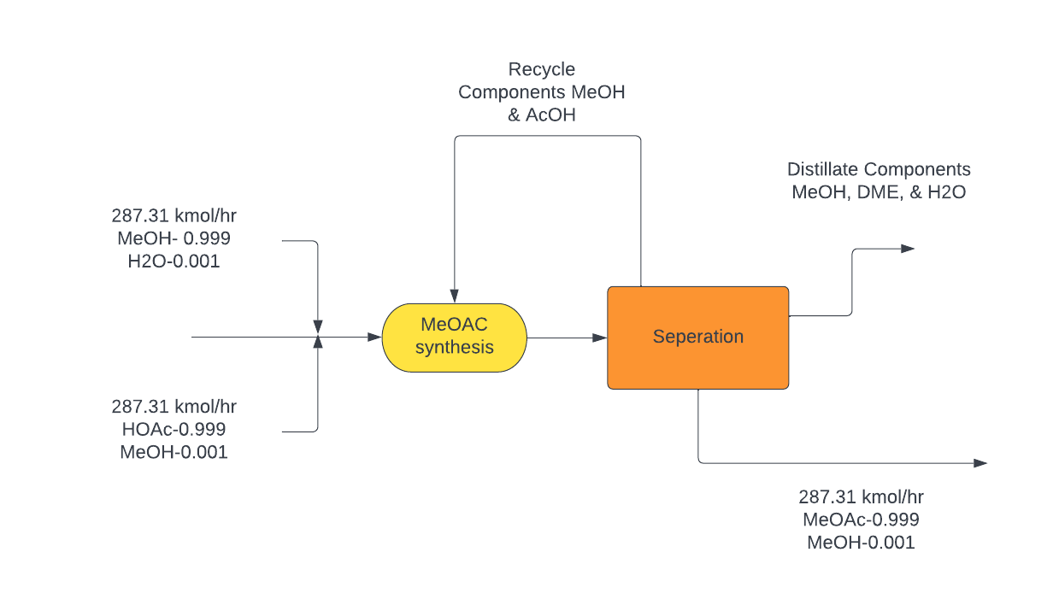

**Figure 1.** Simplified Esterification Block Flow Diagram

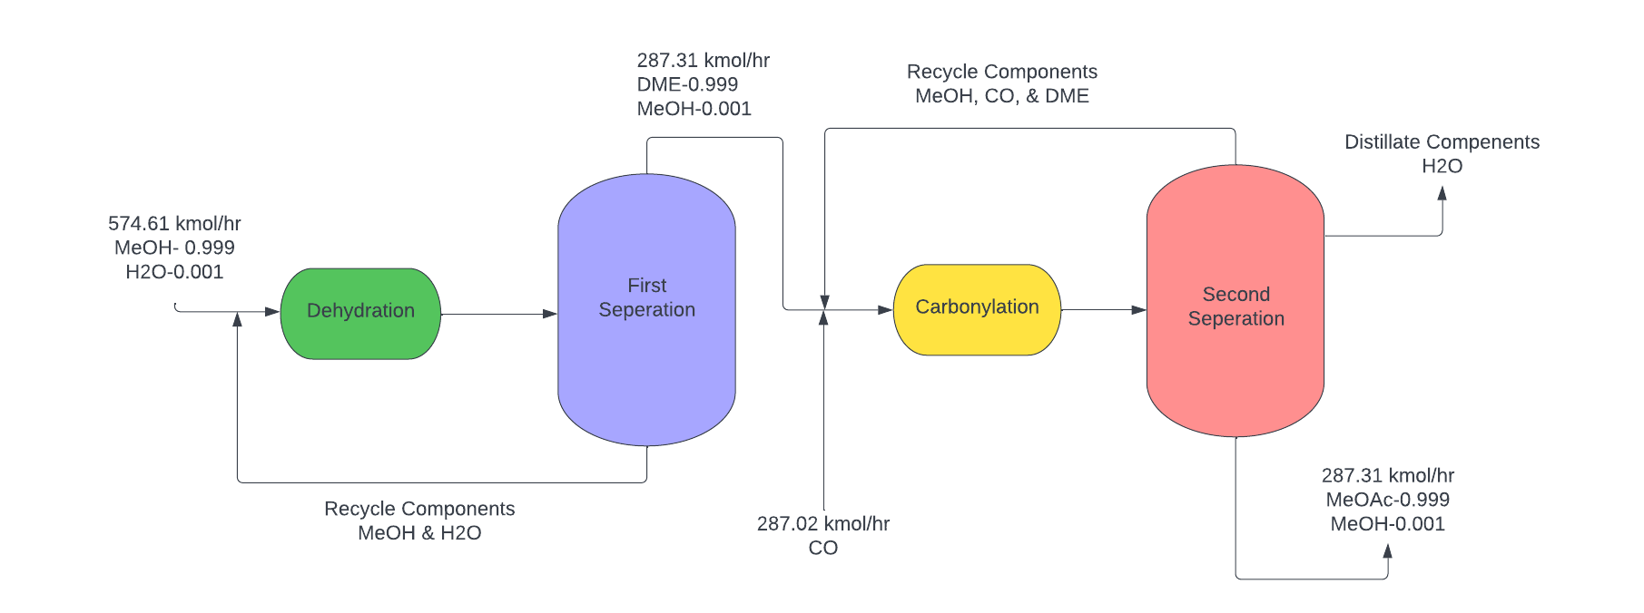

**Figure 2.** Simplified Carbonylation Block Flow Diagram

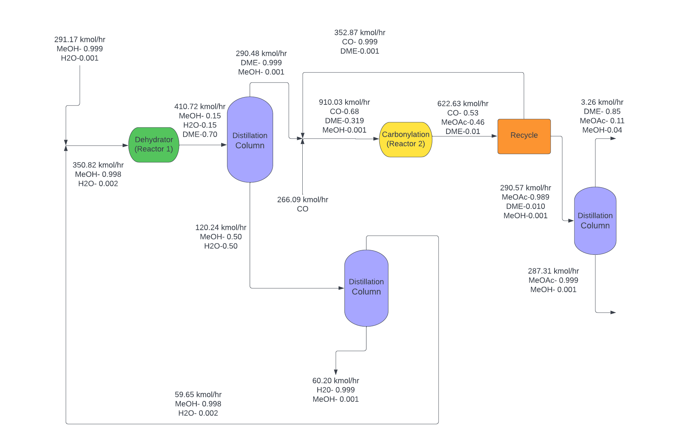

**Figure 3.** Rigorous Carbonylation Block Flow Diagram

**Preliminary Economic Analysis**

In the preliminary economic analysis, it was assumed that the ingredient costs 100% contributed to the variable costs (VC). Since the desired NROI is 25% with a tax rate of 25%, the NROI equation in **Eq. B1** (**Appendix B**) can be rearranged to have a relationship between just the revenue (R) and the fixed investment (FI).

To better understand the relationship between R and FI, a parameter of the ratio between carbonylation FI (FIC) and esterification FI (FIE) is introduced. The FIC is varied for each ratio to solve for R. From the desired production rate, the transfer price (tP) of the product for the carbonylation process can be calculated. This is repeated for the esterification process, by using FIE from the FIC value pre-determined and the ratio chosen. The difference in the transfer price between carbonylation and esterification (tP,C - tP,E) is then computed. The calculation is repeated for a range of ratios, and the graph of difference in tP vs. FIC is plotted for each ratio, to obtain a family of curves. From these family of curves, the intersection point of the curves at the x-axis are extracted. These intersections represent the critical fixed investment of the carbonylation process for that particular ratio, which is used to plot **Figure 4**.

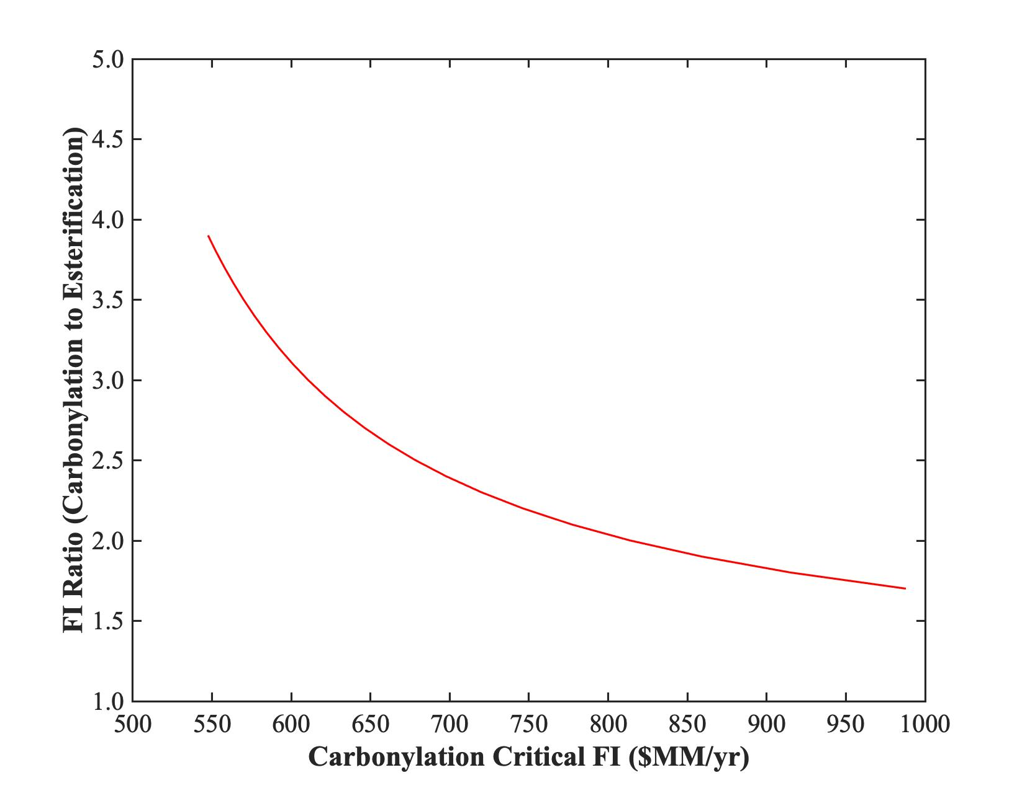

**Figure 4.** Relationship between FI ratio to critical FI of carbonylation.

The hyperbola in **Figure 4** tells us where the investment is more feasible from the other investment route. For example, if the FIC is at $850MM/yr with a ratio of 3.5, it would suggest that it is better to invest in the esterification route. In other words, if the FIC is at the lower left of the hyperbola, investing in the carbonylation route is more feasible. Moreover, the vertical asymptote of the hyperbola tells the engineer important information, where the FIE is zero. What this suggests is that the engineer can invest in both routes, but this is never true in the real world.

This information can aid the engineers to decide which route to invest in. From a rough estimate of the carbonylation fixed investment (less than $100MM/yr), with a rough FI ratio of 0.5 (FIC:FIE), it is very feasible to invest in the carbonylation route. The major reason why the esterification process requires more investment is because of the usage of acetic acid. It corrodes the carbon steel equipment, which requires the utilization of a more expensive material, stainless steel.

**Conclusions and Limitations** Based on the locus of critical investment values, it is clear that the carbonylation route is more feasible than the esterification. This is further substantiated by the high conversion rate assumed for esterification (which is unlikely due to this reaction being in equilibrium). A lower conversion would require higher variable costs, which could further decrease the NROI. However, there are a few limitations to the analysis carried out at this stage. There was an assumption of 100% yield, which is unlikely due to competing side reactions, which would further increase variable costs. Furthermore, the distillation columns are assumed to be 100% efficient, which isn’t likely and could result in an increase in the number of columns.

**References**

1. R. Bertrum Diemer and William L. Luyben

Industrial & Engineering Chemistry Research 2010 *49* (23), 12224-12241

DOI: 10.1021/ie101583j

**Appendices**

***Appendix A: Determination of Batch vs Continuous Process***Now, it has been stated that the desired acetic anhydride (Ac)2O and methyl acetate (MeOAc) production are 500 and 375 MMppy. Thus, to obtain the mass amount per year, the following calculations were carried out.

$500⋅10^{6}\frac{lb}{yr}×\frac{1kg}{2.205lb}×\frac{1 ton}{1000kg}=226,796 tonnes/yr$

$375⋅10^{6}\frac{lb}{yr}×\frac{1kg}{2.205lb}×\frac{1 ton}{1000kg}=170,097 tonnes/yr$

This value is greater than 5,000 tonnes/yr, which proves that the continuous process is preferred to the batch process in this scenario.

***Appendix B: NROI calculation***

$NROI=(1-t)\left(\frac{R-0.06[VC+0.14FI+0.8n]-VC-0.14FI-0.8n}{FI+\frac{VC}{6}+\frac{0.14}{12}FI+0.067n}\right)$**Eq. B1**

**Table B1.** Notation used in NROI determination

| **Notation** | **Definition** | **Values/Unit** |
| --- | --- | --- |
| NROI | Net return on investment | % |
| t | Fractional tax rate | 0.25 |
| R | Revenue | $ |
| FI | Fixed investment | $ |
| VC | Variable cost | $ |
| n | Operators/shift | - |

**Eq. B1** is the simplification of the NROI equation, leaving only the variables R, VC, FI, n, and t. Since the known variables are VC, n, and t, it is up to the engineers to vary FI to solve for R. VC is found by calculating the ingredient costs for each route. n is found by using the block flow diagram for each process. For a process, 1 control manager is needed for the overall plant with 1 process worker per 2 major equipment (such as 1 reactor and 1 column, or 2 reactors).